**SYSTEM ANALYSIS AND DESIGN**

**Team Member**

-Eng. Dalia Mostafa

-Eng. Hesham Qutb

-Eng. Hadeer Abdel Nasser

**Pharmaceutical Company**

**System request:**

***Business needs:***

**Our business needs separated into some targets to be provided**

**- Increase income**

**- Original product**

**- Ease of obtaining the product**

**- Easily paid**

**Functionality:**

**1- Provide online access to connect to the company.**

**2- Search & select about the desired drug.**

**3- Payment process will be in cash or mobile services.**

**Business requirements:**

**-Concept of database.**

**-Concept of web.**

**-Concept of network.**

**-Web service.**

**Tangible value:**

**-Participate in the services provided.**

**-Return of Partnership Company.**

**Intangible value:**

**-Save time and effort.**

**- Ease of obtaining the original product**

**Use case diagram:**

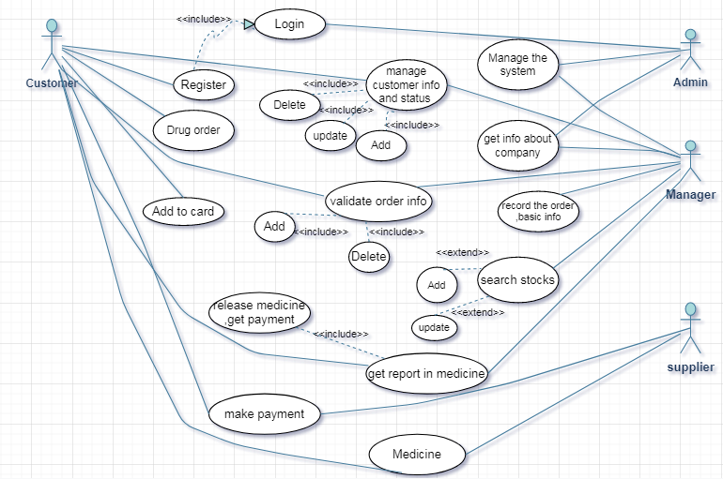

**use case in details:**

**Use case : Register**

ID: UM1

Priority: High

Actor: Customer ,pharmacy ,doctor ,hospital

Description : the user registered for the system and make order

Trigger : user should meet the admin and select the "Register Users"

Type: External

Pre-Condition : user is not logged in

Normal case :

-User types a user name of his or her choice

. User types a password-

. User retypes the password-

Submit-.

. System checks if the user name is not already in use-.

. -System checks if the two passwords are identical.

. -System registers the new user with the give.

Post-condition: user become a registered

Alternative course : User name is already in use

User is requested to select another user name and password.

-The two passwords are different

. User is requested to retype (twice) his/her password

**Use case : Manage customer info**

ID: UM2

Priority: High

Actor: System ,Admin

Description : the Admin submit the customer info in the system and checking up

Trigger : after user registered the admin checking up and update info and save it

Type: External

Pre-Condition : the customer info is not updated

Normal case :

1-the admin enter customers's name ,password and id in the system of the company .

2- update the info

3- submit

Post-condition: the customer's info is update at the system

Alternative course : User name is already in use

User is requested to select another user name

**Use case : Drug order**

ID: UM3

Priority: high

Actor: patient ,doctor, hospital ,pharmacy

Description : Here the user begins to order medicines and medical equipment from the company

Trigger : The user must write or choose the medicines he needs

Type: External

Pre-Condition : there is not have a order

Normal case :

= -The user begins to give the names of the medicines to the manager

= -The user determines the amount of these drugs

-After that, the manager collects the required drug items in a report and sends it to the stocks

Post-condition: we have the customer order

Alternative course :

-Writing used to idolize medicines by mistake

- validate order info

**Use case : Record the order and Basic info**

ID: UM4

Priority: high

Actor: Manager ,System

Description : manager validate order info and make a report of order and send it to stocks

Trigger : make a report of order and send it to the stocks

Type: internal

Pre-Condition : the order info not recorded

Normal case : The manager makes a report of order info

Post-condition: the order info is recorded

Alternative course : there is not a report

**Use case : Search Stocks**

ID: UM5

Priority: high

Actor: manager

Description : At this stage, the manager checks the report and compares the types of drugs and whether they are available or not

Trigger : checking if the types of drugs available or not

Type: internal

Pre-Condition : we don’t know if the drugs types is available or not

Normal case :

-Managers check the types of drugs in the report if they are available or not.

-The third step, after making sure that it is available, the manager makes a file for that and completes the sale process.

-In the second case, if the types of medicines are not available in the company, the manager informs the client of this and ends the sale

Post-condition: we make sure that drugs types is available

Alternative course:

-The third step, after making sure that it is available, the manager makes a file for that and completes the sale process.

-In the second case, if the types of medicines are not available in the company, the manager informs the client of this and ends the sale.

**Use case : Get report in medicines**

ID: UM6

Priority: high

Actor: System ,manager

Description :

After verifying that the medicines are available in the company, the manager stores this application and completes the process

Trigger : the order is ready

Type: internal

Pre-Condition : The order is not ready for payment

Normal case :

After verifying that the medicines are available in the company, the manager stores this application and completes the process

Post-condition: The product is ready for payment

Alternative course :

**Use case:** **Payment**

ID: UC7

Priority: high

Actor: Customer, suppliers

Description:

A process in which the customer choose how to pay

Trigger:

Pay for medication

Type: External

Pre-condition:

The company is not paid for the medicine

Normal case:

Determine the Quantity of medicines and items

Customer pays the fees in any way (cash , visa card , Telecommunications companies)

Post condition:

The company paid for the medicine

Alternative course:

Customer does not have the fees in cash -

Pay fees by visa

Pay fees by telecommunications companies’ services-

If the visa is empty-

Pay fees by telecommunications companies’ services